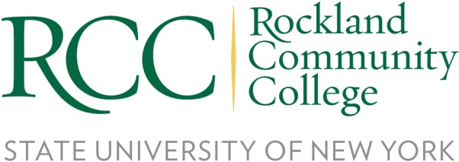

FOR IMMEDIATE RELEASE
Contact: Risa B. Hoag, GMGPR, 845-627-3000, risa@gmgpr.com

Rockland Community College Announces Spring Open House
April 20th from 4pm to 7pm

ROCKLAND COUNTY (April 10, 2023) – Rockland Community College is hosting an in-person Open House on April 20th from 4pm to 7pm at the Main Campus in Suffern. It is a great opportunity for potential students and their families to tour the campus with current RCC students who will offer their own take on life at RCC. Attendees can meet with representatives from Financial Aid, Student Success and Specialized Services; Academic Deans will be hosting breakout rooms to assist students in finding the right academic program.
Registration Link for Open House: https://apply.sunyrockland.edu/register/openhouse_spring23

The College will also be offering a series of academic program information sessions for careers in Occupational Therapy, Business, and Hospitality & Culinary Arts. In addition to these, there are several other academic programs and workforce development programs available for exploration, including Nursing, Legal Studies (Criminal Justice, Legal/Paralegal Studies and Corporate Homeland Security) and Gas Utility Worker training. You can access more information on these programs by following this link https://sunyrockland.edu/admission/sessions/

About Rockland Community College, State University of New York
Rockland Community College (RCC), located in Suffern New York, provides purpose-driven educational opportunities in a supportive, affordable, and accessible environment, empowering individuals to positively transform themselves and their communities. RCC welcomes students from diverse backgrounds who appreciate small class sizes and personal attention from a distinguished, award-winning faculty that includes Fulbright scholars and SUNY Distinguished Professors. Many graduates go on to top universities to further their education on their own or through RCC’s institutional collaborations.

RCC also provides career training and professional development to adult learners looking to change careers or upgrade their skills through a variety of programs and educational opportunities including workforce training, certifications, and microcredentials. Many of the programs are developed with employers in the community in high-demand industry areas to enable graduates to move into a new career upon graduation. More information can be found at sunyrockland.edu.

###

