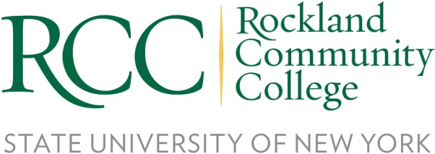

FOR IMMEDIATE RELEASE
Contact: Risa B. Hoag, GMGPR, 845-627-3000, risa@gmgpr.com

RCC’s 33rd Annual Chess Event and Exhibition

ROCKLAND COUNTY (April 12, 2023) – While the series “The Queen’s Gambit” encouraged a lot of people to try their hand at chess, students at Rockland Community College have understood the intrigue of this board game for over three decades. On Tuesday, April 18th at 12:30, Rockland Community College will host the 33rd Annual Chess Event and Exhibition from 12:30pm to 3:00pm, in the Student Union, Room 3214, on the main campus in Suffern, NY. The Chess Event is open to all RCC students, employees and community members. Each school district in Rockland County was invited to send two students to the event.

The Chess Event is the highlight of the year for RCC's Chess Club. It will give students and members of the community the opportunity to interact with International Grandmaster Gennadij Sagalchik and play a game of chess with him. Grandmaster Sagalchik, originally from Belarus, is a renowned chess player and leading US chess coach. Three-time Pan-American Intercollegiate Champion, he led the teams of Manhattan Community College and Brooklyn College. He is a 2002 US Championship participant and the top prize winner of numerous international tournaments. Currently living in Brooklyn, Grandmaster Sagalchik is working with over 350 students and serving as the head coach for Chess Mates, a rapidly growing scholastic chess organization on Long Island, New York.

"Chess is similar to life, you plan ahead, you move forward and sometimes you have to take a step back and reconsider your position. The only difference is that in chess, everyone starts at the same position, a plane field. Come and see how far you can get, and don't worry about your skill level, remember that every chess master was once a beginner," said Alexander Urena Jimenez, a Co-President of the Chess Club and Business Administration major from Pomona NY.

Please contact Peter Arvanites, Professor of Mathematics, at 845-574-4767 or Peter.Arvanites@sunyrockland.edu for more information.

About Rockland Community College, State University of New York
Rockland Community College (RCC), located in Suffern New York, provides purpose driven educational opportunities in a supportive, affordable, and accessible environment, empowering individuals to positively transform themselves and their communities. RCC welcomes students from diverse backgrounds who appreciate small class sizes and personal attention from a distinguished, award-winning faculty that includes Fulbright scholars and SUNY Distinguished Professors. Many graduates go on to top universities to further their education on their own or through RCCs institutional collaborations. RCC also provides career training and professional development to adult learners looking to change careers or upgrade their skills through a variety of programs and educational opportunities including workforce training, certifications, and microcredentials. Many of the programs are developed with employers in the community in high-demand industry areas to enable graduates to move into a new career upon graduation. More information can be found at sunyrockland.edu.

###

