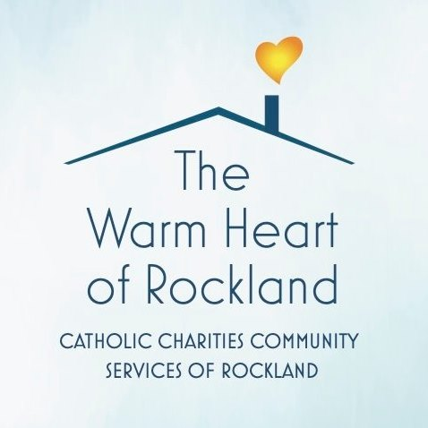
FOR IMMEDIATE RELEASE
CONTACT: Risa B. Hoag, GMGPR, 845-627-3000, risa@gmgpr.com

Catholic Charities Community Services of Rockland to Host
“Hearts of Gold” Gala – Members of Local Parishes to be Honored

ROCKLAND (May 22, 2023) -- On Thursday, June 15th Catholic Charities Community Services of Rockland (CCCSR) will host their Gala Dinner after a three-year hiatus. The event will take place at Town & Country at 922 Route 9W in Congers. CCCSR will recognize a member of each of the 14 parishes in Rockland County for their “hearts of gold.” The honorees were nominated by their respective Pastors for their dedication and commitment to their own parish ministry.

“We are thrilled to be able to celebrate so many individuals who give back to their communities on a regular basis through our annual Hearts of Gold Gala. We are also happy to be able to get back together in person for this event after a long break due to the pandemic,” stated Dan Eudene, Executive Director of Catholic Charities Community Services of Rockland which assists with food insecurity and housing issues for those facing eviction. It also operates Rockland County’s Warming Center to help house individuals without shelter during the colder months.

Dinner Details
The Hearts of Gold gala will start with a social hour at 6:00pm and then dinner from 7:00pm to 9:00pm. Tickets are available for purchase for $125 each or two for $235. Corporate and organizational sponsorship and journal advertising opportunities are also available by contacting LuAnn Kelley at 845.942.5791, ext. 1012 or LuAnn.Kelley@ccrockland.org For more information, visit: www.ccrockland.org

During the evening CCCSR will also recognize their annual sponsors including Madeline Wiebicke of Keller Williams, Rand Commercial, Club Pilates and Mercedes-Benz of Nanuet.

Catholic Charities Community Services of Rockland is an affiliate of the Catholic Charities of the Archdiocese of New York and is a not-for-profit 501c3 social service agency established in 1996 by the eighteen Catholic parishes of Rockland County. Through compassionate and professional case management, Catholic Charities Community Services of Rockland assists individuals and families of all ages, from every race, and ethnic group from throughout Rockland County regardless of their religious affiliation. The organization’s focus is to provide the necessities of life, such as food, shelter and emergency assistance for those in need. Programs include information and referral, general case management, homelessness and eviction prevention, emergency financial assistance, nutritional outreach and education, street outreach, the warming center, a food pantry, and immigration legal services.

In an average year CCCSR:
- Provides ​150,000+ meals through the Food Pantry to over 4,900 households, including 6,826 adults, 1,221, elderly, and 8,724 children
- ​Distributes 10,000 pounds of fresh vegetables to Food Pantry participants from the Community Garden of Love located on the property along with donated produce from Stoke’s Farms
- ​​Gets support from 40+ dedicated volunteers help to prepare, bag, and distribute food
- Serves over 200 individuals in the Warming Center
- Keeps over 100 households from losing their shelter

About Catholic Charities Community Services of Rockland
Catholic Charities Community Services of Rockland, The Warm Heart of Rockland, provides services to people of all ages, from every race and ethnic group from all over the County. The organization’s focus is to provide life necessities, including food, shelter and other emergency assistance to those in need. The compassionate and professional staff speak English, Spanish, French and Creole, and assist people of all ages, races and religions in Rockland County. CCCSR also runs the Warming Center for Rockland County during the colder months. More information can be found at www.ccsrockland.org or by calling (845) 942-5791.
# # #

