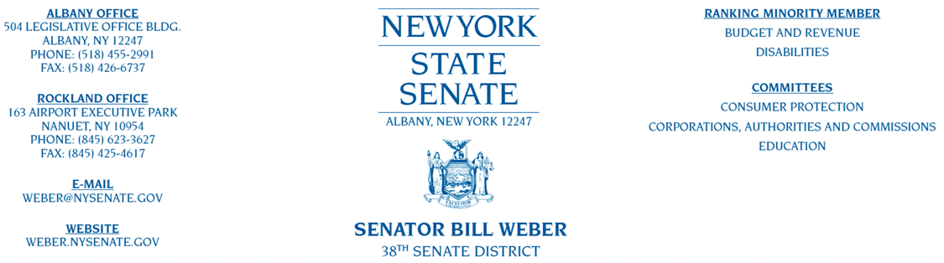

July 24th, 2023

Dear Friends,

I am pleased to announce that I am hosting the Annual NYS Senate Senior Fair. This year’s fair will be held on Thursday, September 14, 2023, from 10 AM to 2 PM, in the Rockland Community College Field House at 145 College Road in Suffern, NY. Setup for the event will begin at 9 AM.

Our goal for this event is to highlight businesses, services, and organizations within Rockland County and the surrounding areas that look to support and enhance the lives of the senior citizen population in our community.

I encourage businesses, non-profit agencies, as well as cultural, educational, and/or historical groups in the area to be vendors at our event. This fair is an excellent way to attract new members and customers, and I know your organization will serve as a valuable resource for our senior community. I hope you will consider being a vendor at this year’s event.

**The deadline to register as a vendor is Tuesday, August 29th. Note that there is no charge for participation in this event.** Enclosed, please find our vendor application form. If you would like to participate, complete this form and return it to my office by mail at 163 Airport Executive Park, Nanuet, NY 10954. You may also submit the completed form to Mulgrew@NYSenate.gov

I am confident that your participation will enhance the experiences of our senior citizen community, and I look forward to seeing you in September. If you have any questions, please feel free to contact us at 845-623- 3627.

Sincerely,



Senator Bill Weber

38th Senate District

**Senator Bill Weber’s Annual NYS Senate**

**Senior Fair Vendor Application**

**Thursday, September 14, 2023, 10 AM to 2 PM**

Organization: ______________________________________________________________

Type of Resource (select one):

**Healthcare / Finance / Recreation / Education / Culture / Government**

**Other:** ________________________________________________________________

Contact Person: _____________________________________________________________

Address: ____________________________________________________________________

Phone: ______________________________________________________________________

Email: _______________________________________________________________________

Special Requests:_____________________________________________________________

**Vendor Guidelines**

∙ Vendor space will only be reserved by completing and returning the application.

∙ Vendors are required to stay for the entire duration of the event.

∙ Vendor set up will be from 9 AM to 10 AM.

∙ Vendors can drop supplies at the field house entrance and then find appropriate parking.

∙ Vendors will be supplied with 1 table and 2 chairs.

∙ No balloons are allowed in the fieldhouse.

∙ **Due to the configuration of the fieldhouse to accommodate the elderly or disabled, electrical outlets will not be available. Outlets for charging are limited; if you need electricity for your laptop, please arrive with your battery fully charged.**

Please return applications to:

Office of Senator Weber

163 Airport Executive Park, Nanuet, NY 10954

Phone: 845-623-3627 • Fax: 845-425-4617

Email: Mulgrew@NYSenate.gov

**The deadline to register is Tuesday, September 5, 2023**